* Create a responsive web page as per the provided mock-ups for Desktop, Tablet & Mobile breakpoints using **HTML5, CSS3 & JavaScript** for this assignment.
* The copy/content for the webpage should be dynamically populated in the HTML elements by calling JSON API (for e.g. <https://eclerx.com/wp-json/wp/v2/posts/39145>, <https://eclerx.com/wp-json/wp/v2/posts/51641>) and using JSON data from the JSON API response as shown below.

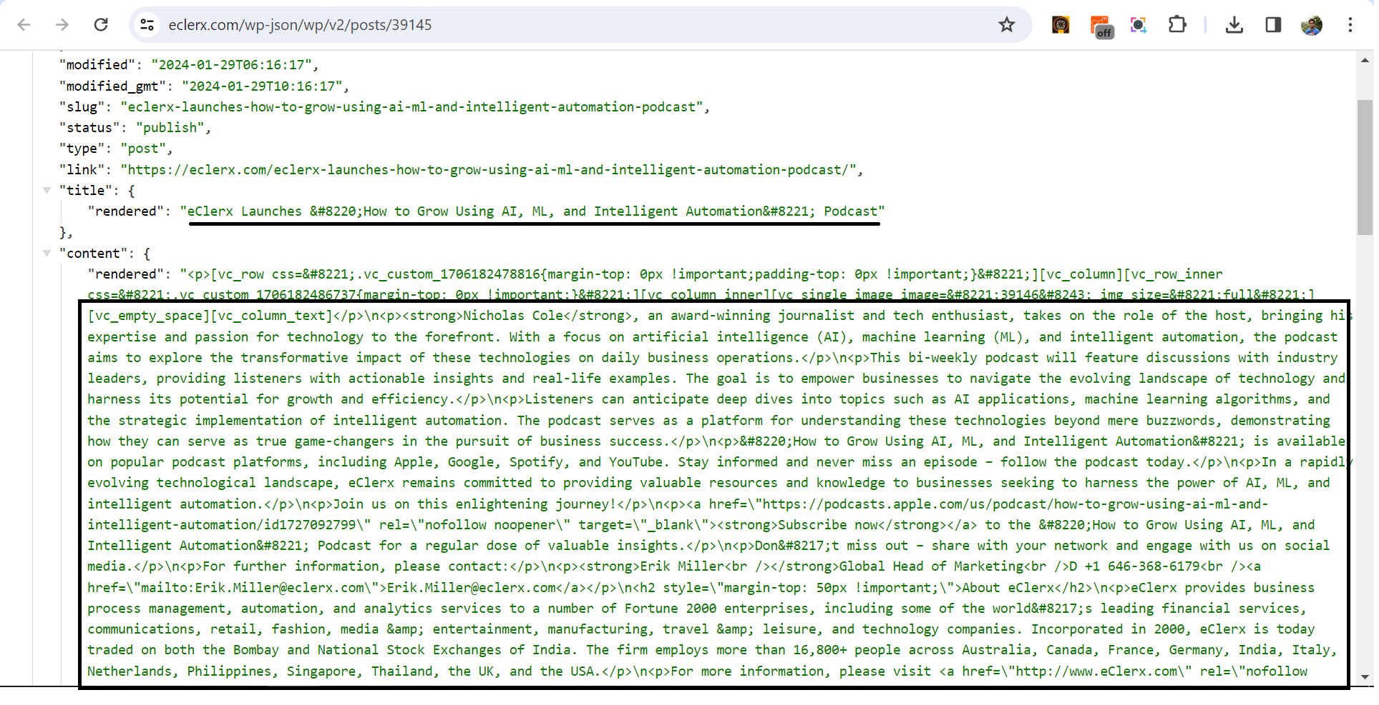

* Required images are given in ‘**assets**’ folder for all breakpoints.
* Implement below functionalities in the webpage –

1. Table of Contents –

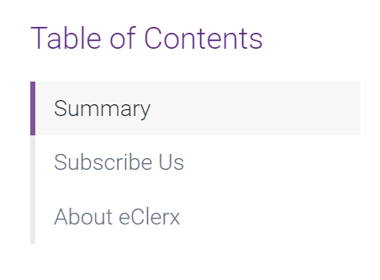

* Table of Contents section should always be sticky and be visible to user all the time.
* On clicking of any Table of Contents anchor link, the page should be scrolled to its matching section.
* For e.g. On click of “About eClerx” link, page should be scrolled to About eClerx section

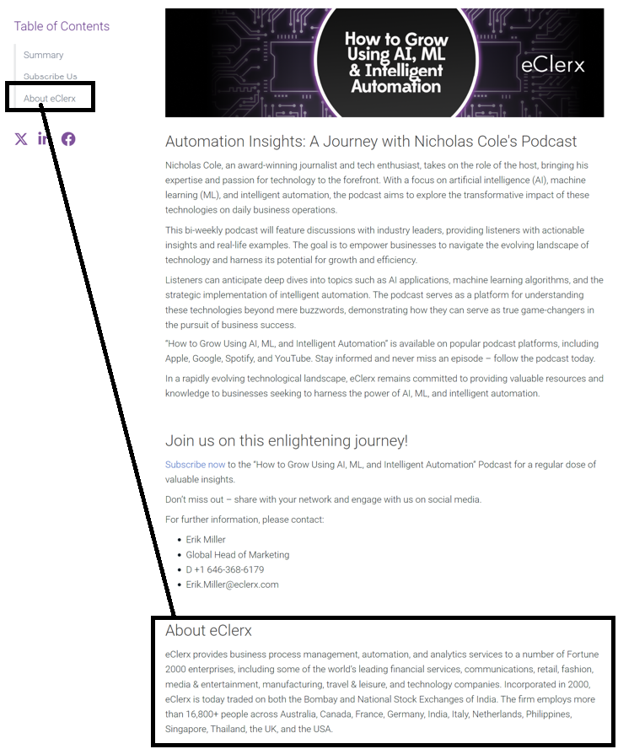

1. Social Media Share buttons.



* Font awesome icons can be used for social media icons.
  + <https://fontawesome.com/v6/icons/x-twitter?f=brands&s=solid>
  + <https://fontawesome.com/v6/icons/linkedin-in?f=brands&s=solid>
  + <https://fontawesome.com/v6/icons/facebook?f=brands&s=solid>
* On clicking of any social media icons, new window should open up to share the page on the respective social media platform.

1. Back to Top button.



* + On click of Back to top button, the page should be smooth scrolled back to the top of the page.

1. Slider for browsing multiple blogs.
   * Any 3rd party slider library can be used.
   * Only 3 cards should be in the view for Desktop & Tablet viewport, and only 1 card for mobile view.
   * Desktop –

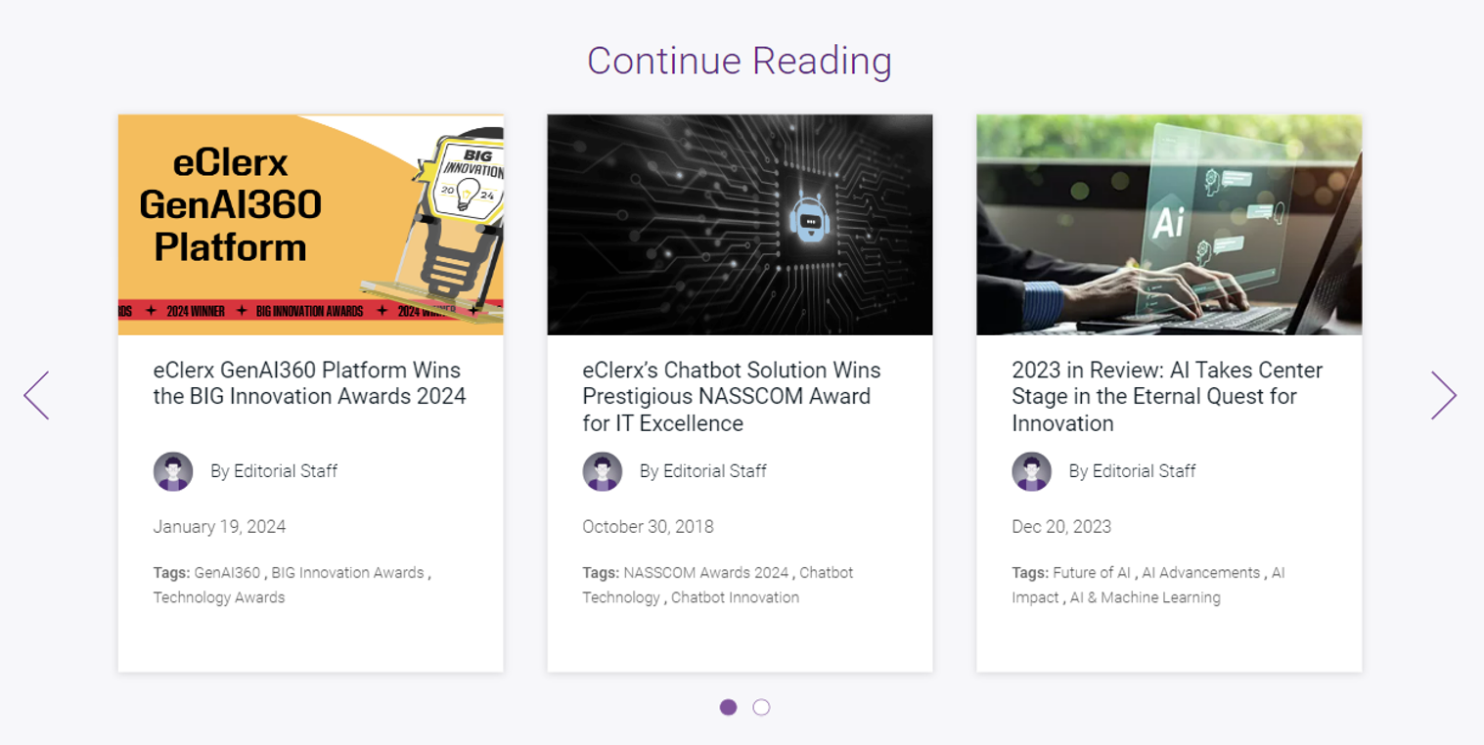

* Mobile –

